**Experiment 4**

**Aim:** To design the half subtractor and full subtractor circuit by using the XOR, NOT, AND and NAND gates and verify their truth table.

**Theory:** Subtractor circuits take two binary numbers as input and subtract one binary number input from the other binary number input. Similar to adders, it gives out two outputs, difference and borrow (carry-in the case of Adder). There are two types of subtractors.

* Half Subtractor
* Full Subtractor

Half Subtractor Circuit: The half-subtractor is a combinational circuit which is used to perform subtraction of two bits. It has two inputs, X (minuend) and Y (subtrahend) and two outputs D (difference) and B (borrow). The logic symbol and truth table are shown below.

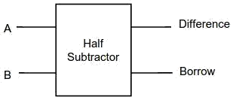

*Fig 1: Block Diagram of Half Subtractor Circuit*

|  |  |  |  |
| --- | --- | --- | --- |
| Input | | Output | |
| A | B | Difference | Borrow |
| 0 | 0 | 0 | 0 |
| 0 | 1 | 1 | 1 |
| 1 | 0 | 1 | 0 |
| 1 | 1 | 0 | 0 |

*Table 1: Truth Table of Half Subtractor Circuit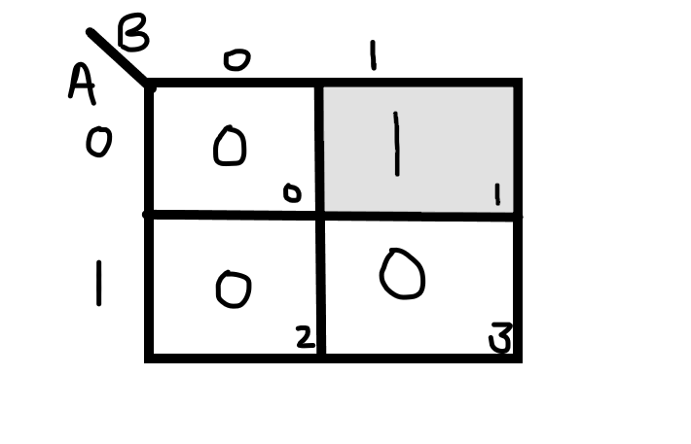*

*Fig: K-map for Difference Output Line for Half Subtractor Circuit*

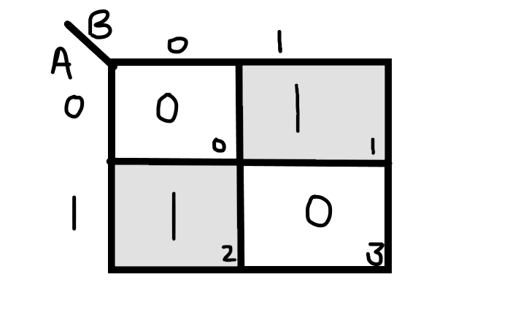

*Fig: K-map of Borrow Output Line for the Half Subtractor Circuit*

From the above truth table and K- map we can find the boolean expression as:

**D = A ⊕ B**

**Bout = A' Y**

From the equation we can draw the half-subtractor circuit using XOR, OR, AND and NAND gates.

Full Subtractor Circuit: A full subtractor is a combinational circuit that performs subtraction involving three bits, namely minuend, subtrahend, and borrow-in. It accepts three inputs: minuend, subtrahend and a borrow bit and it produces two outputs: difference and borrow. The logic symbol and truth table are shown below.

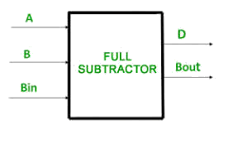

*Fig 2: Block Diagram of Full Subtractor Circuit*

|  |  |  |  |  |
| --- | --- | --- | --- | --- |
| Input | | | Output | |
| A | B | Borrow Input (Bin) | Difference (D) | Borrow Output (Bout) |
| 0 | 0 | 0 | 0 | 0 |
| 0 | 0 | 1 | 1 | 1 |
| 0 | 1 | 0 | 1 | 1 |
| 0 | 1 | 1 | 0 | 1 |
| 1 | 0 | 0 | 1 | 0 |
| 1 | 0 | 1 | 0 | 0 |
| 1 | 1 | 0 | 0 | 0 |
| 1 | 1 | 1 | 1 | 1 |

*Table 2: Truth Table of Full Subtractor Circuit*

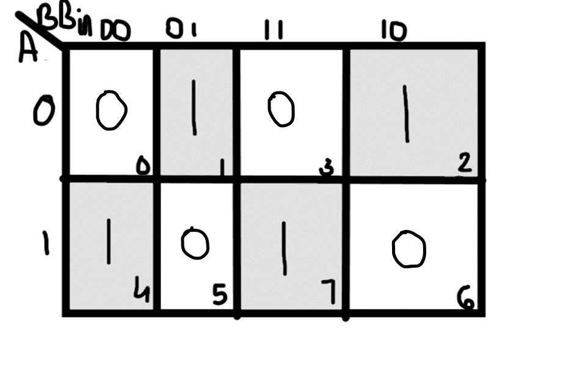

*Fig: K-map for Difference Output Line for Full Subtractor Circuit*

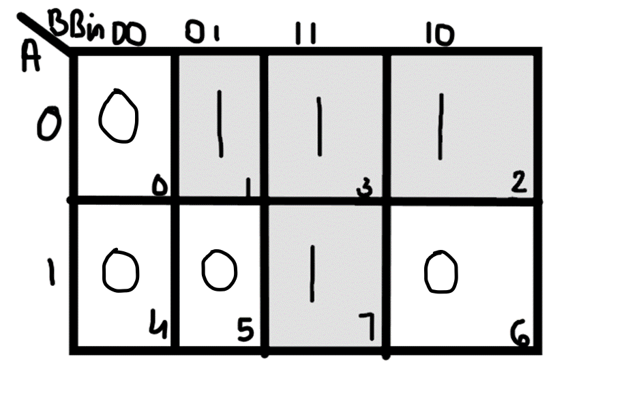

*Fig: K-map for Borrow Output Line for Full Subtractor Circuit*

From the above truth table we can find the boolean expression as:

**D = A ⊕ B ⊕ Bin  
B = A' Bin + A' B + B Bin**

From the equation we can draw the Full-subtractor circuit using XOR, OR, AND and NAND gates.

**Observations:**

1. Half Subtractor:

The circuit representation of Half Subtractor Circuit using:

1. XOR, OR and AND Gates:

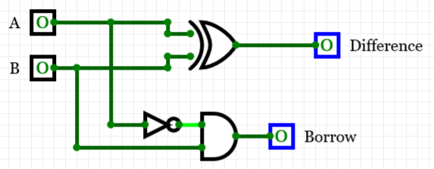

1. NAND Gate:

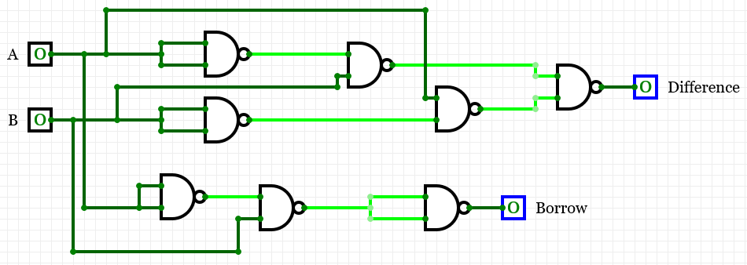

1. Full Subtractor:

The circuit representation of Full Subtractor Circuit using:

1. XOR, OR and AND Gates:

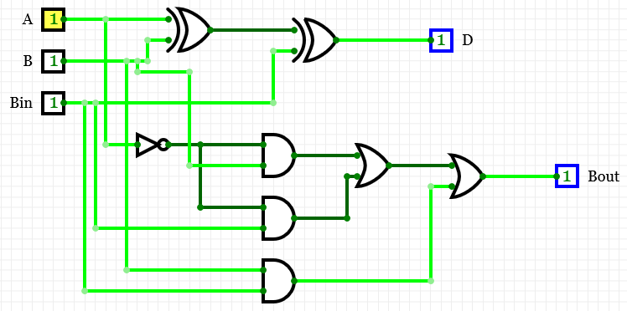

OR

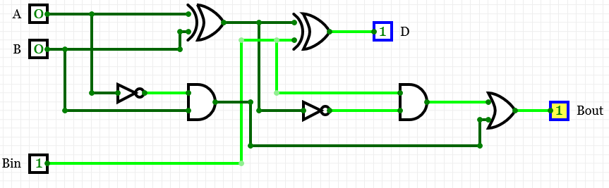

(Using Half Subtractor Circuit)

1. NAND Gate:

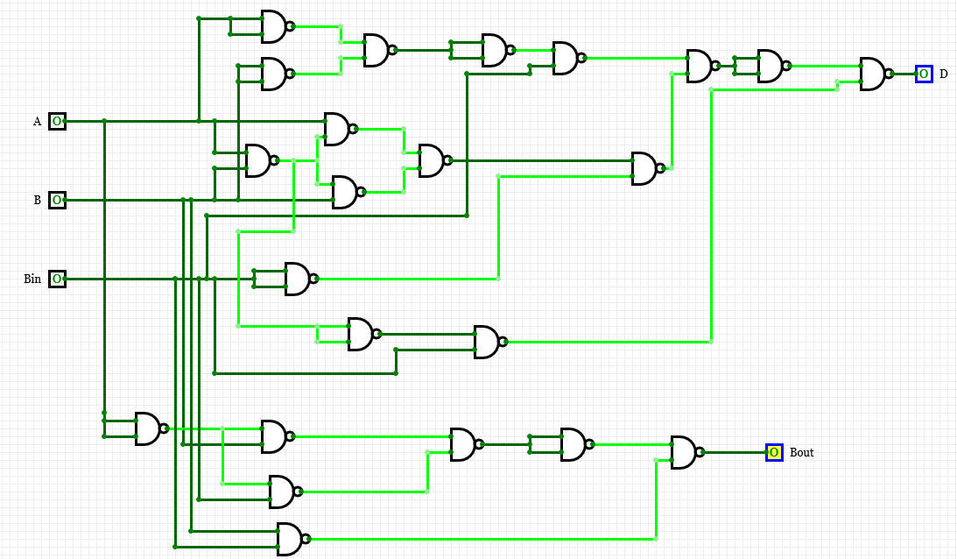

**Result:** The operation of Half Subtractor and Full Subtractor Circuit has been verified successfully.

|  |  |  |  |
| --- | --- | --- | --- |
| **CRITERIA** | **TOTAL MARKS** | **MARKS OBTAINED** | **COMMENTS** |
| 1. **CONCEPT** | **2** |  |  |
| 1. **IMPLEMENTATION** | **2** |  |  |
| 1. **PERFORMANCE** | **2** |  |  |
| **TOTAL** | **6** |  | |